EXP: Program to count number of elements in a list.

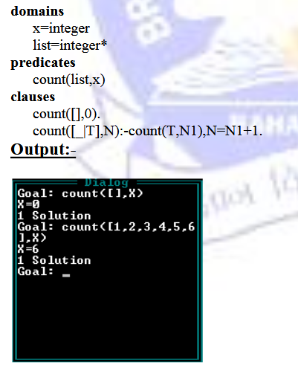

PROGRAM : Program to append and reverse the list.

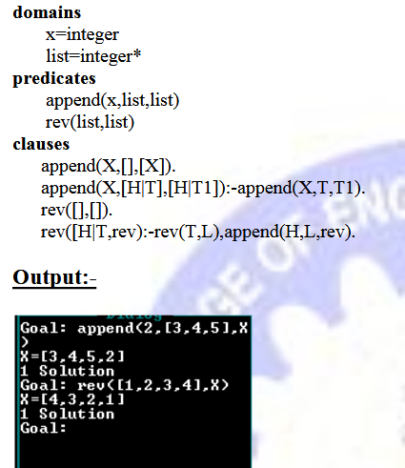

PROGRAM 11: Program to demonstrate family relationship.

predicates

parent(symbol,symbol)

child(symbol,symbol)

mother(symbol,symbol)

